- List 3 real-world devices in your home or college that use SMPS (Switched Mode Power Supply) and 2 devices that use UPS (Uninterruptible Power Supply), explaining in one line why each device needs that type of power supply.
Ans :- SMPS (Switched Mode Power Supply): Converts electrical power into the correct voltage needed by electronic devices.
Device | Why it uses SMPS
1. Desktop computer | Converts AC power into different DC voltages required by computer components.
2. Laptop charger | Converts AC electricity from the wall into DC power for the laptop.
3. Mobile phone charger | Converts AC power into low-voltage DC power to charge the phone.
UPS (Uninterruptible Power Supply): Provides temporary backup power when the main electricity supply fails.
Device | Why it uses UPS
1. Desktop computer | Provides backup power so the user can save work and shut down safely.
2. Wi-Fi router | Keeps the internet connection running for some time during a power cut.
- Draw and label a diagram showing the main internal components of a typical SMPS unit found in a desktop PC, including AC input, rectifier, transformer, and DC output sections.<br><br><em><strong>Hint:</strong> You can hand-draw and upload a photo, or use any free diagram tool like draw.io.</em>
Ans :- AC Input (230 V AC)
Electricity from wall socket
- EMI Filter
Reduces electrical interference
- Rectifier
Converts AC into DC
- Switching Circuit
Switches DC at high frequency
- High-Frequency Transformer
Transfers energy and provides isolation
- Output Rectifier and Filter
Produces smooth DC voltages
- DC Output: +12 V, +5 V, +3.3 V
Supplies the motherboard, CPU, GPU and storage devices
- The SMPS converts AC electricity into stable DC voltages required by a desktop computer.

- Take photos or find clear images online of the following power connectors: ATX 24-pin motherboard connector, SATA power connector, Molex connector, and PCIe 6/8-pin connector. For each, write its name, the devices it powers, and one safety tip for connecting/disconnecting it.
Ans :-
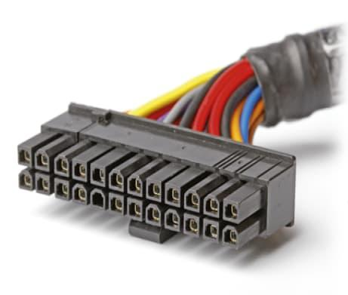
1. ATX 24-pin motherboard connector
- Powers: The motherboard and its main circuits.
- Safety tip: Align the clip with the socket and push until it locks. Switch off and unplug the PC first.

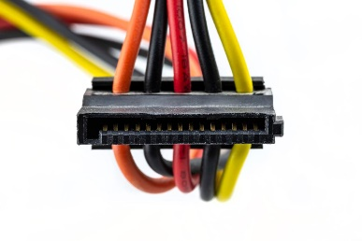
2. SATA power connector
- Powers: SATA hard disk drives (HDDs), solid-state drives (SSDs) and some optical drives.
- Safety tip: Match the L-shaped connector before inserting it; never force it.

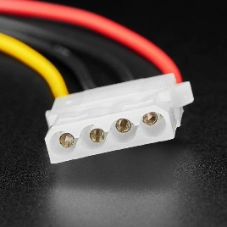
3. Molex 4-pin connector
- Powers: Older hard drives, optical drives, and some case fans or accessories.
- Safety tip: Hold the plastic plug when disconnecting it; do not pull the wires.

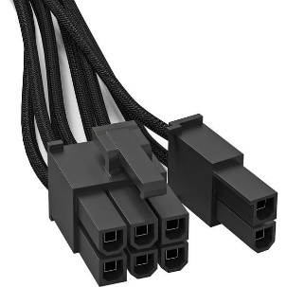
4. PCIe 6/8-pin connector
- Powers: Graphics cards (GPUs) that require additional power.
- Safety tip: Use the correct PCIe cable, not the similar-looking CPU power cable, and ensure the connector is fully seated.
- Imagine you are setting up a new gaming PC. List the steps you would follow to connect the SMPS to the motherboard, graphics card, and storage devices, mentioning which specific cables and connectors are used for each.
Ans :- 1. Switch off the power. Turn off the PSU, unplug the power cord, and place the computer on a stable surface.
2. Connect the motherboard. Use the 24-pin ATX power cable from the SMPS and insert it into the motherboard's main power socket until the clip locks.
3. Connect the CPU power. Use the 4+4-pin CPU/EPS cable and connect it to the CPU power socket, usually near the top-left of the motherboard.
4. Connect the graphics card. Use the required PCIe 6-pin, 8-pin (6+2), or specified GPU power cable. Some newer graphics cards use a 12V-2x6 connector instead, so follow the graphics card manufacturer's instructions.
5. Connect storage devices. Use a SATA power cable from the SMPS to power SATA HDDs, SSDs, and optical drives. Connect a separate SATA data cable from each SATA drive to the motherboard.
6. Connect other components. If required, use SATA or Molex power connectors for compatible fans, lighting controllers, or accessories.
7. Check all connections. Make sure the connectors are fully seated and the cables do not block fans.
8. Start the computer. Close the case, connect the power cord, switch on the PSU, and start the PC. Check that the system starts normally.
> Motherboard
24-pin ATX
- CPU
4+4-pin CPU/EPS
- Graphics card
PCIe 6/8-pin or specified GPU connector
- SATA HDD/SSD
SATA power + SATA data
- Older drives/accessories
Molex 4-pin, if required

